2 MARK

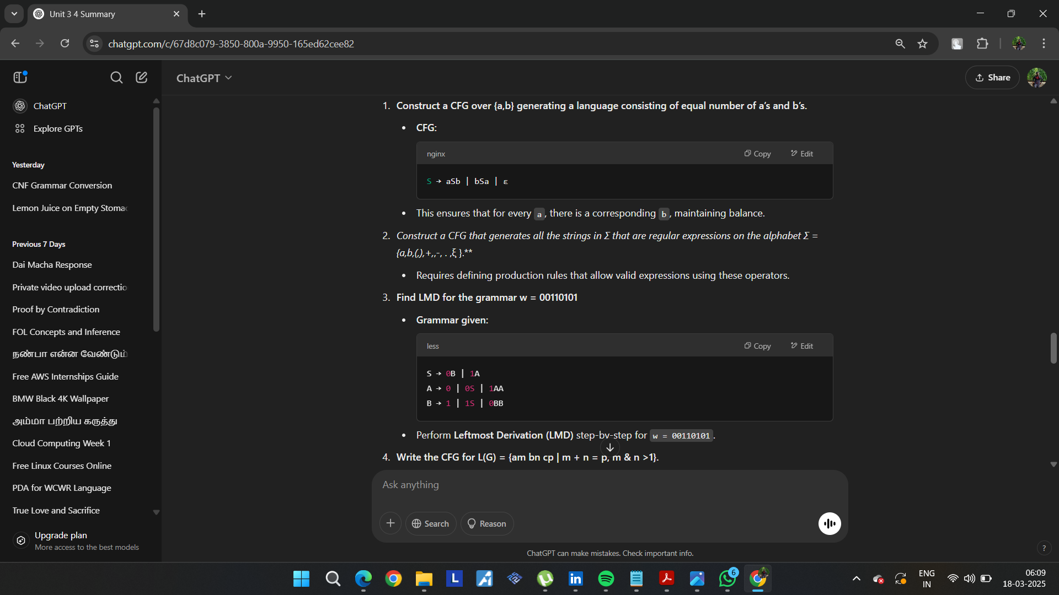
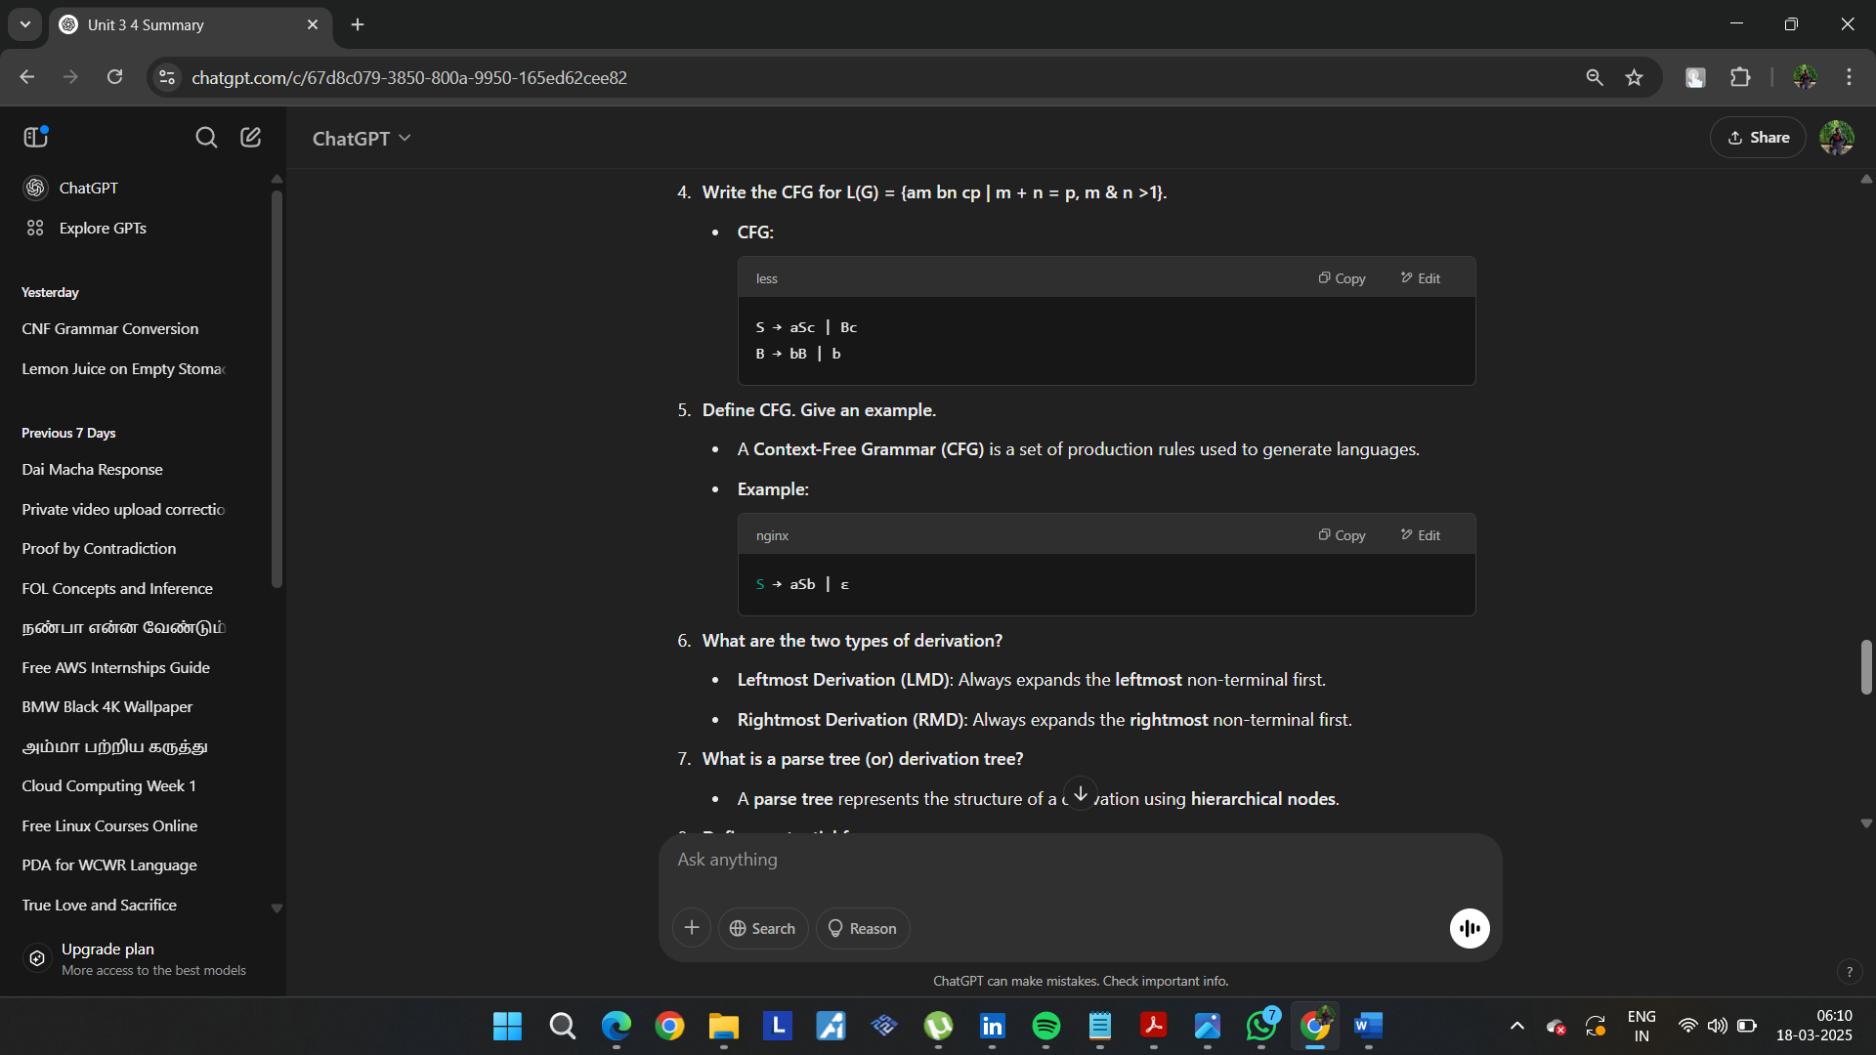
• What are the two types of derivation?
- Leftmost Derivation (LMD): Always expands the leftmost non-terminal first.
- Rightmost Derivation (RMD): Always expands the rightmost non-terminal first.
• What is a parse tree (or) derivation tree?
- A parse tree represents the structure of a derivation using hierarchical nodes.
• Define sentential form.
- A sentential form is any string derived from the start symbol using grammar rules.
• Define Pushdown Automata (PDA).
- A PDA is a computational model that extends finite automata with a stack to handle context-free languages.
• Construct a PDA that accepts the language generated by the grammar
S → aSbb
S → aab
δ(q, a, Z0) → (q, aZ0)
δ(q, a, a) → (q, aa)
δ(q, b, a) → (q, ε)
δ(q, b, a) → (q, ε)
Construct a grammar for L = {an | n is odd}.
- CFG:

S → aSa | a
A language is accepted by final state if the PDA reaches an accepting state after reading the input.
What are the different ways of language acceptance by a PDA?
- Final State Acceptance: The PDA reaches a final state.
- Empty Stack Acceptance: The stack is empty at the end of input processing.

Unit 3 – Context-Free Grammars (CFG)
15. Classify the grammar based on Noam Chomsky Hierarchy.
- The Noam Chomsky Hierarchy classifies grammars into four types:
  - Type 0 (Unrestricted Grammar): Can generate any recursively enumerable language.
  - Type 1 (Context-Sensitive Grammar - CSG): Rules are of the form α → β, where |α| ≤ |β|.
  - Type 2 (Context-Free Grammar - CFG): Rules have a single non-terminal on the left-hand side (A → γ).
  - Type 3 (Regular Grammar): Rules are of the form A → aB or A → a, generating regular languages.

16. Construct a CFG for the language L = { aⁿ bⁿ | n ≥ 0 }.
- CFG:
- S → aSb | ε
- This ensures equal numbers of a and b in the correct order.

Unit 4 – Pushdown Automata (PDA)
17. Draw PDA accepting the language L = { aⁿ c bⁿ | n > 0 }.
- Transitions:
  - Push a onto the stack.
  - Read c without modifying the stack.
  - Pop a when encountering b.
  - Accept when the stack is empty.
- The PDA operates by pushing a on the stack for every input a, ignoring c, and popping for each b.

18. What is an instantaneous description of PDA?
- An Instantaneous Description (ID) of a PDA represents its current state, remaining input, and stack content in the form:
- (q, w, γ)
- Where:
  - q is the current state.
  - w is the remaining input.
  - γ is the current stack content.

19. Define Deterministic PDA.
- A Deterministic PDA (DPDA) is a PDA where:
  - For each state and input symbol, at most one transition exists.
  - No ε-moves are allowed (except under specific conditions).
- DPDAs cannot recognize all context-free languages, unlike non-deterministic PDAs (NPDAs).

20. Does a Pushdown Automata have memory? Justify.
- Yes, a PDA has memory in the form of a stack.
- The stack allows a PDA to remember an arbitrary number of symbols, enabling it to recognize context-free languages.

21. What is the additional feature PDA has when compared with NFA? Is PDA superior over NFA in the sense of language acceptance? Justify.
- Additional Feature:
  - A PDA has a stack, which gives it the ability to recognize context-free languages.
  - An NFA (Non-deterministic Finite Automaton) does not have a stack and can recognize only regular languages.
- Superiority:
  - Yes, PDA is superior to NFA in terms of language acceptance because:
    - NFA can only accept regular languages.
    - PDA can accept context-free languages, which are more powerful than regular languages.

Let me know if you need explanations or diagrams for PDA constructions! 🚀
----------------------------------------------------------------------------------------------------------------------------------------------
Here are the answers to the Unit 4 (CO5) questions:

Context-Free Grammars and Normal Forms
- Give the general forms of CNF.
  - Chomsky Normal Form (CNF) requires that all production rules be of the form:
    - A → BC, where A, B, and C are non-terminals, and B & C are not start symbols.
    - A → a, where a is a terminal.
    - S → ε (if the language contains an empty string).

- Name any four closure properties of regular languages.
  - Regular languages are closed under:
    - Union (L1 ∪ L2 is regular).
    - Concatenation (L1L2 is regular).
    - Kleene Star (L* is regular).
    - Intersection (L1 ∩ L2 is regular).

- State the two normal forms and give an example.
  - Chomsky Normal Form (CNF)
  - S → AB | a
  - A → a | b
  - B → b
  - Greibach Normal Form (GNF)
  - S → aA | bB | a
  - A → a | bA
  - B → b
  - In GNF, the right-hand side must start with a terminal.

- Convert the given grammar into Greibach Normal Form (GNF):
- S → ABb | a
- A → aaA | B
- B → bAb
  - The conversion involves eliminating left recursion and ensuring that each rule starts with a terminal.

- Is L = {aⁿbⁿcⁿ | n ≥ 1} context-free? Justify.
  - No, L is not context-free.
  - This language requires a PDA to compare three different counts (a, b, c), which is not possible with a single stack.
  - Proof: Pumping Lemma for CFLs fails.

- Find L(G) for:
- S → aCa
- C → aCa | ε
  - The language contains palindromes with an equal number of 'a' on both sides, e.g., {aa, aaaa, aaaaaa, ...}.

- Find the language generated by the given CFG:
- S → aSb | ab
  - The language consists of strings with equal numbers of 'a' and 'b' in balanced pairs:
{ab, aabb, aaabbb, ...}.

- Convert the given grammar into an equivalent one with no unit productions and no useless symbols.
  - The conversion involves:
    - Removing unit productions (A → B).
    - Eliminating unreachable or useless symbols.

- Construct a CFG without ε-productions:
- S → a | Ab | aBa
- A → b | ε
- B → b | A
  - After removing ε-productions:
  - S → a | Ab | aB | aBa
  - A → b
  - B → b | b

- Convert the given grammar by removing unit productions and useless symbols.
  - Remove unit productions:
  - S → CB
  - B → 1B | 1
  - C → 0C | 0
  - Final equivalent grammar:
  - S → CB
  - B → 1B | 1
  - C → 0C | 0

Turing Machines (TM) and Automata
- Compare Finite Automata (FA) and Turing Machine (TM).
  - FA: Accepts regular languages.
  - TM: Accepts recursively enumerable languages, has unlimited memory, and can perform computation.

- Define GNF with an example.
  - Greibach Normal Form (GNF): Each production must start with a terminal.
  - A → aB
  - B → bC | ε
  - C → c

- What is a Turing Machine?
  - A Turing Machine (TM) is a mathematical model of computation that manipulates symbols on an infinite tape according to a set of rules.

- Preliminary simplifications applied to grammars before conversion to normal forms:
  - Removing ε-productions.
  - Removing unit productions.
  - Eliminating useless symbols.

- What is a multiple-track Turing machine?
  - A multiple-track TM has multiple rows on its tape, allowing parallel processing of different data.

- Construct a TM for computing the 2’s complement of a binary number.
  - Steps:
    - Scan from left to right, find the first 1, and invert the remaining bits.
    - Transition between states to perform this operation.

- List out different techniques for TM construction.
  - Storage in Tape
  - Multiple Tracks
  - Multiple Tapes
  - Non-Deterministic TM (NTM)
  - Universal TM (UTM)

- What are the conventional notations of PDA?
  - A PDA is represented as:
  - M = (Q, Σ, Γ, δ, q₀, Z₀, F)
Where:
    - Q = Set of states
    - Σ = Input alphabet
    - Γ = Stack alphabet
    - δ = Transition function
    - q₀ = Start state
    - Z₀ = Initial stack symbol
    - F = Set of accepting states

- Design a TM that accepts the language of even integers written in binary.
  - Steps:
    - Move right until the last digit.
    - Check if the last digit is 0 (even number).
    - Accept if 0, reject if 1.

- Define Multi-Tape TM.
  - A multi-tape Turing Machine has multiple tapes and multiple heads, each operating independently.
  - It can increase computational efficiency by allowing parallel read/write operations.

Let me know if you need explanations or diagrams! 🚀

